**Mensuration Formulas**

.

# All Mensuration Formulas for Triangles:

It is the sum of all three sides of a triangle. Let a, b, and c be the sides of a triangles then:

1. Formula of Perimeter of triangle (P)

= a + b + c

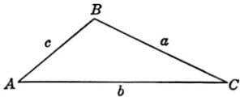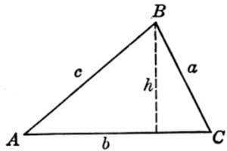

1. Formula of Semi Perimeter of triangle

(s) =({a+b+c}/{2})

The two mostly used mensuration formulas for area of triangle are:

1. Area of triangle = 1  *b*  *h*

2

1. Area of triangle =

*s* *s*  *a**s*  *b**s*  *c*

Some advance mensuration formulas for area of triangle are:

1. 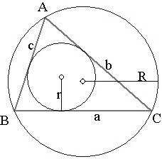Area of triangle = *r*  *s* , where *r* is in-radius of the triangle.
2. Area of triangle =

*abc* , where *R* is circum-

4*R*

radius of the triangle.

1. Area of triangle= 4

*u* *u*  *d* *u*  *e**u*  *f* 

3

,where d, e and f are medians and

*d*  *e*  *f*

*u* 

2

1. Area of triangle= 1  *ab* sin** , where a and b

2

are the two known sides and is the included angle.

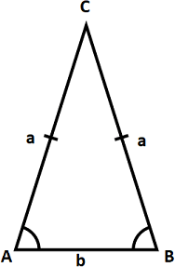Some mensuration formulas for area of special triangle:

1. Area of equilateral triangle = side of the equilateral triangle
2. Area of isosceles triangles =

3 *a*2 , where a is the

4



, where a be

*a*2 

*b*2

4

the measure of the equal sides of an isosceles triangle and b be the base of the isosceles triangle.

# Mensuration Formulas for Circles

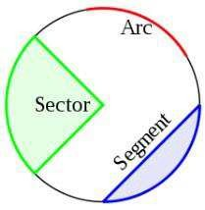Circumference of circle= 2* r*

Area of circle=* r*2

Length of arc= **  2* r*

360

Area of Sector= **  * r* 2

360

Area of Segment= ** * r* 2  1  *r* 2 sin**

360 2

# Mensuration Formulas for Quadrilaterals

1. 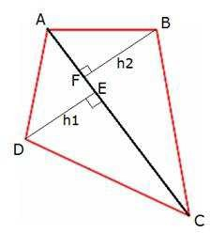Area of any Quadrilateral =

1  *one diagonal* *h*1 *h*2

2

1. Area of any Quadrilateral = 1 ×d d ×sinθ,

2 1 2

where d1 and d2 are the diagonals of the

quadrilaterals and ‘θ’ is the angle between them

1. Area of any Quadrilateral =

, where

(*s*  *a*)(*s*  *b*)(*s*  *c*)(s *d*)  *abcd* cos2 **

** = Average of any pair of opposite angles of

*a*  *b*  *c*  *d*

the quadrilateral and *s* 

2

1. 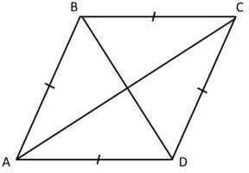Perimeter of Rectangle = 2(length+breadth)
2. Area of Rectangle=length x breadth
3. Perimeter of Square=4a
4. Area of Square = square.

*a*2 , where *a* is the side of the

1. Perimeter of Parallelogram =2(a+b), where a and b are two adjacent sides of the parallelogram.
2. Area of Parallelogram=base x height
3. Perimeter of Rhombus = 4a
4. Area of Rhombus = 1  *d*  *d*

, where d1 and d2 are the two diagonals of the

2 1 2

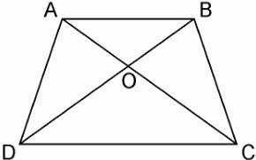Rhombus.

1. Area of Trapezium= 1 *a*  *b* *h* ,

2

where *a* and *b* are the parallel sides of the trapezium and *h* is the perpendicular distance between *a* and *b* .

**Important Trick:**

In any trapezium ABCD, with AC and BD as diagonals intersecting at O, then

Let Area of ∆ AOD = ∆ BOC

Also, we have the following relations:

## Area of ∆ AOB x Area of ∆ COD = Area of ∆ BOC x Area of ∆ AOD

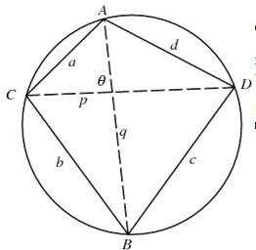A quadrilateral is said to be a cyclic quadrilateral if there is a circle passing through all its four vertices.

## Area =

(*s*  *a*)(*s*  *b*)(*s*  *c*)(*s*  *d*)

* Sum of the opposite angles of a cyclic quadrilateral is **180°**
* If a pair of opposite angles of a quadrilateral is supplementary, then the quadrilateral is cyclic.
* **Ptolemy’s Theorem:** A a cyclic quadrilateral with consecutive sides a, b, c, d and diagonals p, q is cyclic if and only if ac + bd = pq.

# Mensuration Formulas for Polygons

The area of a regular polygon is given by the formula below.

Area = 1

2

(apothem)(perimeter)

Regular Polygon Formulas

*n* = number of sides

*s* = length of a side

*r* = apothem (radius of inscribed circle)

*R* = radius of circumcircle Several other area formulas:

Sum of interior angles = (*n* – 2)·180°

*n*  2

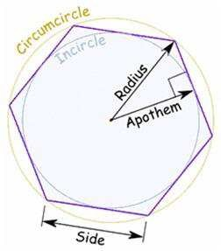Interior angle =

1800 for regular polygons

*n*

Exterior angle =

3600

*n*

for regular polygons

# Mensuration Formulas for Solid (3D) Geometry

## Mensuration Formulas for Cuboid

Total Surface Area of Cuboid

=2(*lw* + *lh* + *wh*), where *l =* length*, w* = width, *h* = height

Volume of Cuboid=*lwh,* where *l*

*=* length*, w* = width, *h* = height

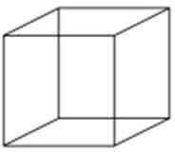**Mensuration Formulas for Cube** Total Surface Area of Cube= 6*a*2 Volume of Cube= *a*3

here *a* is edge length of the cube.

## Mensuration Formulas for Prism

Lateral Surface Area of Prism=perimeter of base × height

Total Surface Area of Prism = 2 × area of base + perimeter of base × height

Volume of Prism = area of base x height

## Mensuration Formulas for Pyramid

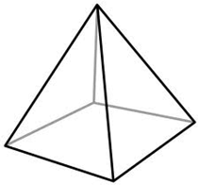Lateral Surface Area of Pyramid= 1  perimeter of

2

base × slant height

Total Surface Area of Pyramid= area of base + area of base + 1  perimeter of base × slant height

2

Volume of Pyramid= 1  area of base x height

2

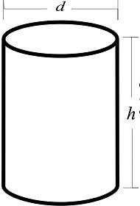**Mensuration Formulas for Cylinder** Curved Surface Area of Cylinder= 2* rh* Surface Area of Cylinder= 2* r* *r*  *h* Volume of Cylinder=* r*2*h*

## Mensuration Formulas of Cone

Curved Surface Area of Cone=* rl*

Height

l = Sqrt *r* 2 + h2 

, whe l = slant

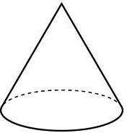

Total Surface Area of Cone=* r* *r*  *l* 

Volume of Cone= 1 * r* 2 *h*

3

## Mensuration Formulas of Sphere

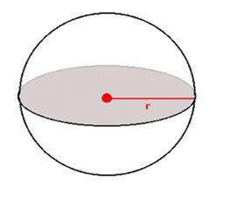

Total Surface Area of Sphere = 4* r*2

Volume of Sphere= 4  * r* 3

3

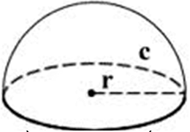**Mensuration Formulas of Hemisphere** Curved Surface Area of Hemisphere= 2* r*2 Total Surface Area of Hemisphere = 3* r*2

Volume of Hemisphere= 2  * r* 3

3